DAV Onslow County Chapter 16 Shirts
There are two “official” shirts for our Chapter.

The first, which we primarily wear during winter months, is the Dickies Short Sleeve Two-Tone Work Shirt in Black and Royal Blue. The common item number for this shirt is DKWS508.

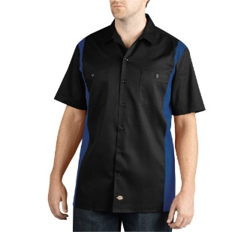

The second shirt, worn primarily in warmer months, is the Dickies Industrial Color Block Polo Shirt in Dark Navy and Smoke. The common item number for this shirt is DKLS424.

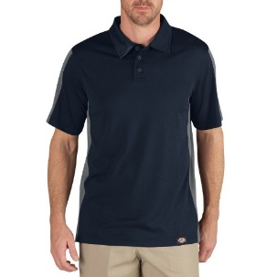

Both of these shirts can be ordered from www.sullivanuniforms.com, though they can also be found on other sites such as Amazon. Check around before you order to make sure you’re getting the best price!

Uniform Caps

Uniform caps are ordered from the DAV Store; caps can be found directly here: https://dav.keystoneuniformcaps.com/ . Males will want the Blue Chapter Cap; females can also wear this cap, but may prefer the DAV WAC Uniform Cap. There is a sizing chart a little further down that page. You can have the store directly embroider your cap for you, but if you are a new member, we encourage you to speak with a member of the Chapter Command staff as the Chapter can have it embroidered locally at no cost to you.

Embroidery

I Need It Now, located on Gum Branch Rd., is the only local business that is permitted to embroider the DAV logo. The logo, along with the words Onlsow County Chapter 16, should be embroidered on the left chest. Your name, if you would like to have it on your shirt, should be on the right chest. The emblem for your branch of service should be on the left sleeve.

If you have any further questions, please call the chapter at (910) 455-3400.

